4. Project Planning Phase

4.1 Development Methodology

An Agile-style iterative methodology is suitable. The project is divided into small deliverables: requirements, design, database, core modules, AI features, testing and documentation. Feedback can be incorporated between iterations.

4.2 Technology Stack
Layer | Technology
Frontend | HTML, CSS, JavaScript or Streamlit UI
Backend | Python with Flask or Streamlit
Database | MySQL
Data Processing | pandas
Database Access | SQLAlchemy / MySQL connector
AI | Rule-based recommendation + optional GenAI API/local model
Development | VS Code
Version Control | Git / GitHub

4.3 Module Planning

Authentication Module

Admin Module

Student Module

Course Module

Enrollment Module

AI Recommendation Module

AI Assistant Module

Reports Module

4.4 Timeline
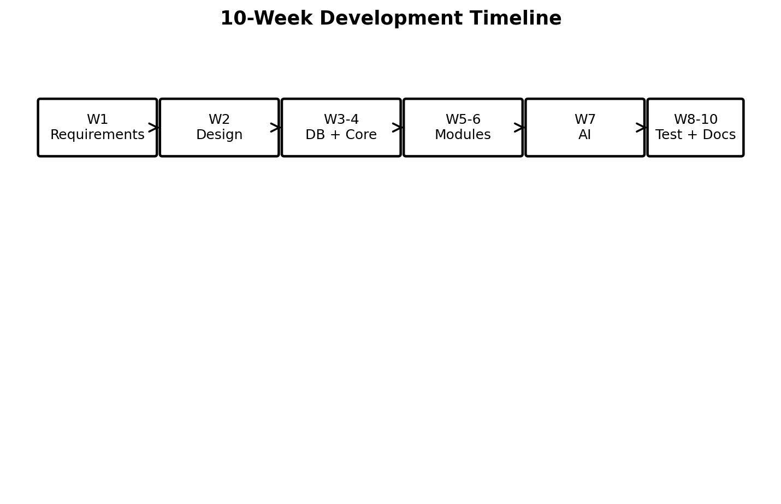4.5 Risk Management
Risk | Impact | Mitigation
Incorrect/duplicate data | High | Validation rules, unique constraints and testing.
Unauthorized access | High | Password hashing, role-based access and session controls.
AI/API unavailable | Medium | Provide rule-based fallback and clear error handling.
Incorrect AI recommendation | Medium | Use eligibility checks and show recommendations as suggestions.
Data loss | High | Regular database backups and recovery testing.
Scope expansion | Medium | Freeze core requirements before adding optional features.
